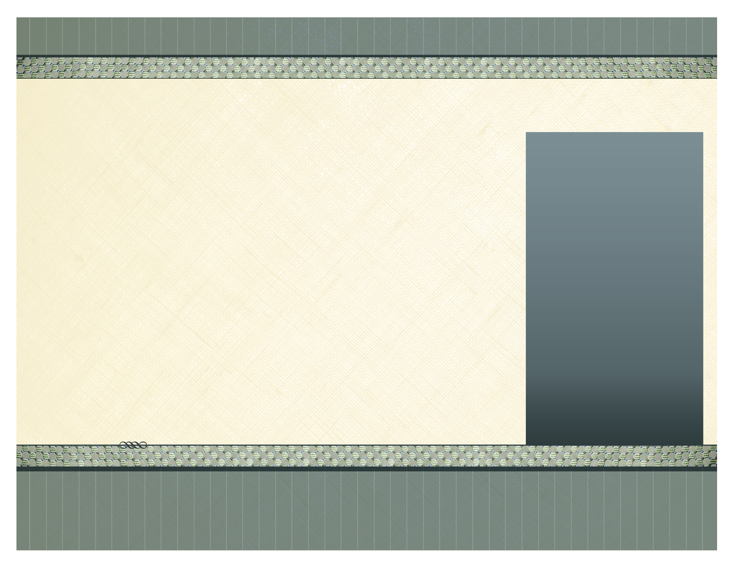
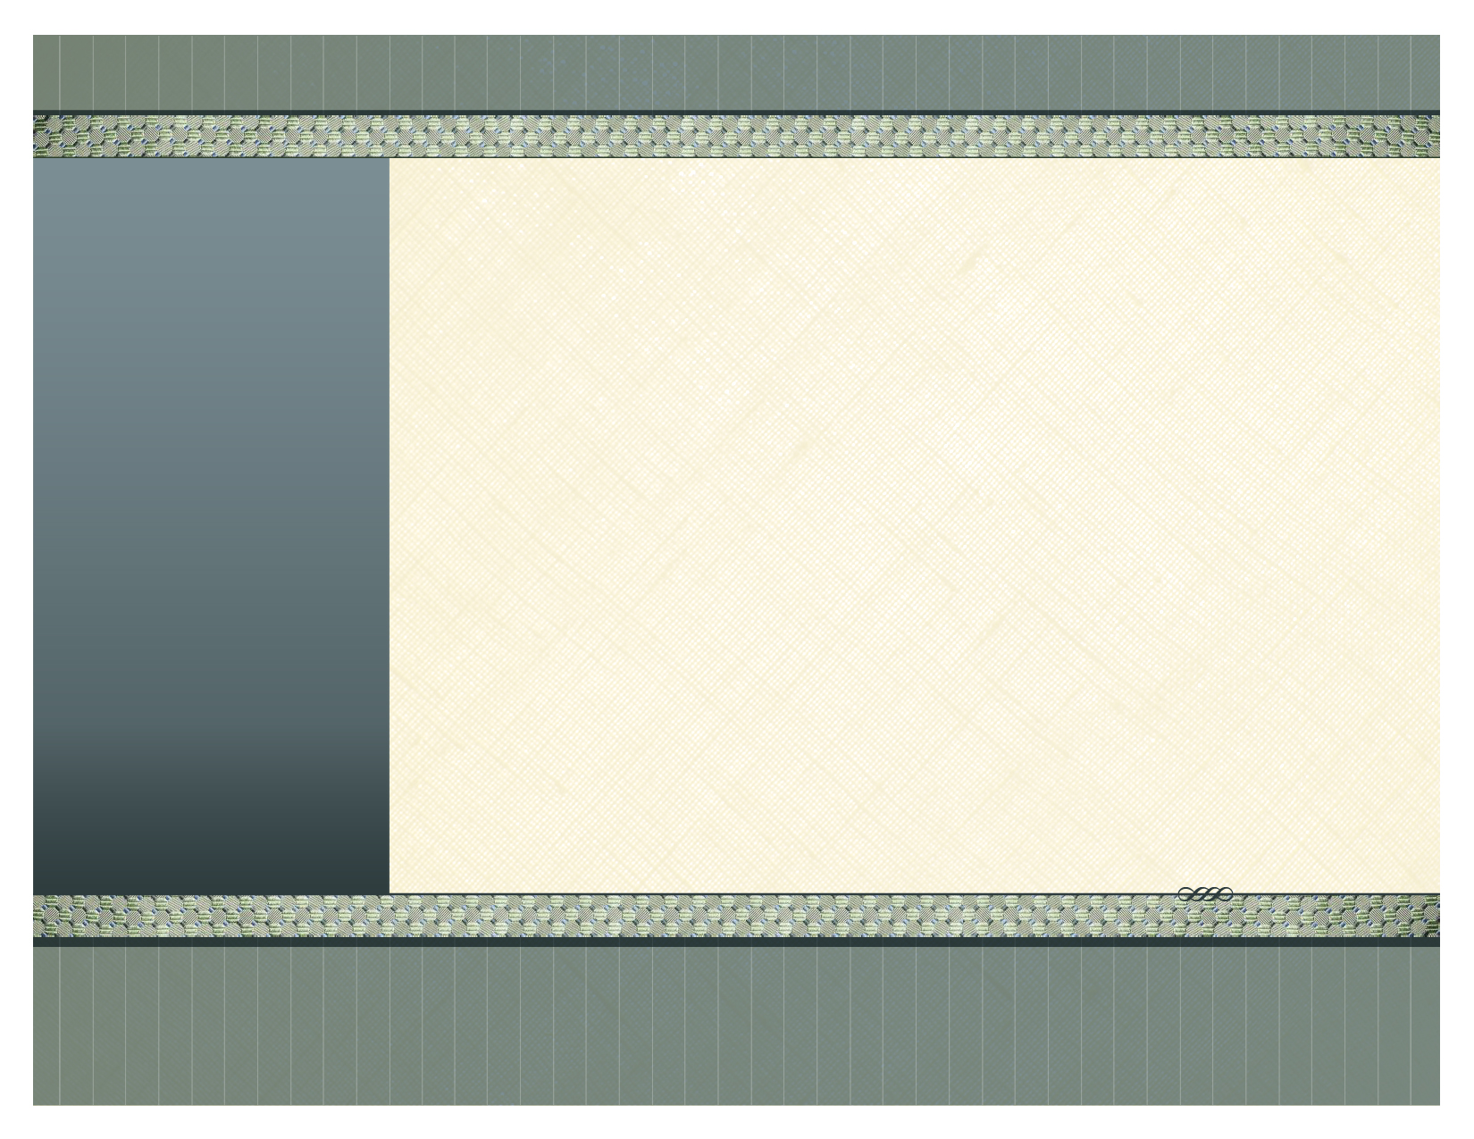
Price includes all importation, delivery to your property, installation, duty costs and VAT.

TERMS ...

50% down payment, and 50% when everything is delivered and fitted.

Kitchen Home Essentials
Set of Kitchen Utensils 1 x Mop & Bucket
24 Piece set of Cutlery 1 x Brush & Dustpan
24 Piece set of dinner ware 1 x Clothes Horse
5 Piece Stainless Steel Pan set 1 x Iron
14 Piece Knife Block Set 1 x Ironing Board
1 x Electric Kettle
1 x 4 Slice Toaster Bed Linen & Towels
1 x Tea/Coffee/Sugar Canister set 4 x Kingsize Flat Sheet
1 x Stainless Steel pedal Bin 4 x Kingsize Fitted sheet
1 x Set of Placemats 2 x Kingsize Summer Quilt
1 x Oven Glove 4 x Kingsize Quilt Cover
1 x Stainless Steel Colander 2 x Kingsize Mattress Protector
1 x Rice Strainer 4 x Single Flat Sheet
1 x Chopping Board 4 x Single Fitted Sheet
1 x Can Opener 2 x Single Summer Quilt
1 x Food Grater 4 x Single Quilt Cover
1 x Potato Peeler 2 x Single Mattress Protector
1 x Bottle Opener 12 x Anti Allergic Pillows
1 x Electric Gas Lighter 12 x Pillow Cases
1 x Dish Drainer 8 x Face Cloths
8 x Wine Glasses 8 x Hand Towels
8 x Tall Glasses 4 x Medium Towels
1 x Water Jug 4 x Large Bath Towels
Bathrooms
3 x Mirrored Cabinet
3 x Chrome effect Towel Rail
3 x Chrome effect Double Robe Hook
3 x Chrome effect Toilet Roll Holder
3 x Chrome effect Toilet Brush

Light Fixtures
Inventory of a variety of light fixtures for your kitchen, bathrooms, living room and bedrooms. Fixtures include wall lights, ceiling fixutres & spot lights.

Blinds & Curtains
Blinds and black-out curtains are measured and made to order with a range of over 200 colours to choose from. Please note, blinds and curtains are not included in the price of this accessory package.

Paradise Beach Resort – Accessories Inventory T3

(Kitchen, Bed, Bath & Lighting)

AIGA Tropical Living

Right of the main Square, Santa Maria, Sal,
Tel: 00238 – 9183330 or 00238 - 9859318
www.aigacaboverde.com Facebook: Aigagroup Caboverde
AIGA Cabo Verde S.A.

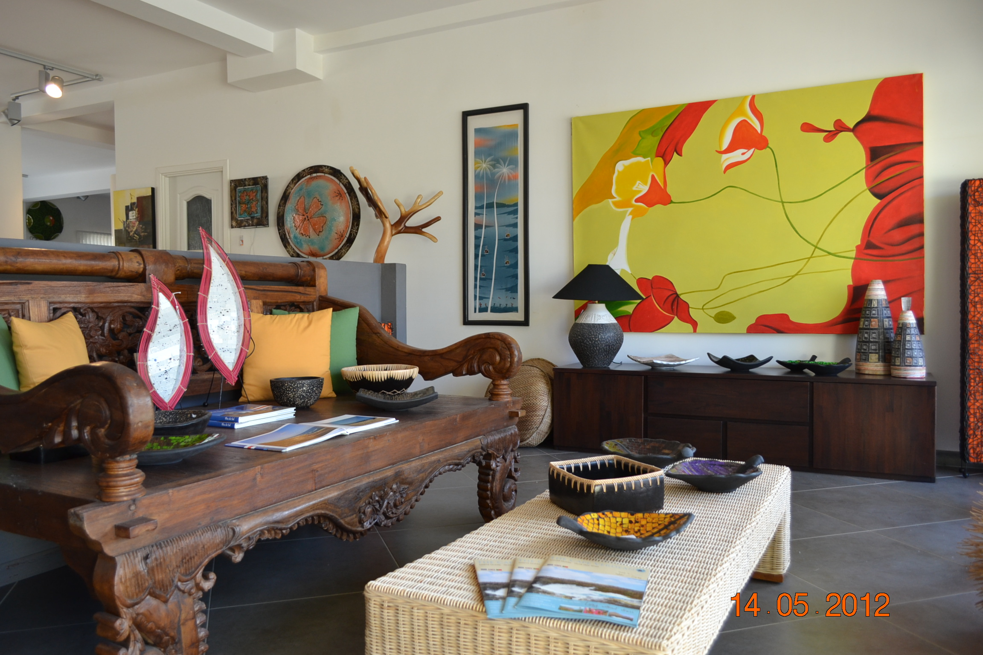

1 x Electric Gas Lighter Bed Linen & Towels Light Fixtures
1 x Dish Drainer 2 x Kingsize Flat Sheet Inventory of a variety of
1 x Wine Glasses 2 x Kingsize Fitted Sheet light fixtures for kitchen,
1 x Tall Glasses 1 x Kingsize Matress Protect bathrooms, living room and
1 x Water Jug 2 x Kingsize Quilt Cover bedrooms. Fixtures include
1 x Kingsize Summer Quilt wall lights, ceiling lights, and
Home Esentials 4 x Single Flat Sheet spot lights.
1 x Iron 4 x Single Fitted Sheet
1 x Ironing Board 2 x Single Summer Quilt Blinds & Curtains
1 x Mop & Bucket 4 x Single Quilt Cover Blinds and curtains are made
1 x Brush & Dustpan 2 x Single Mattress Protect to order with a range of over
1 x Clothes Horse 8 x Anti Allergic Pillow 200 colours to choose from.
8 x Pillow Cases Please note, blinds and
Bathrooms curtains are not included in
2 x Mirrored Cabinet the price of this accessory
2 x Chrome effect Towel Rail package.
2 x Chrome effect Robe Hook
2 x Chrome effect Toilet Roll Holder
2 x Chrome effect Toilet Brush

Kitchen
Set of Kitchen Utensils
24 Piece set of Cutlery
24 Piece set of dinner ware
5 Piece Stainless Steel Pan Set
14 Piece Knife Block Set
1 x Electric Kettle
4 Slice Toaster
Tea/Coffee/Sugar Canister
1 x Stainless Steel pedal Bin
1 x Set Placemats
1 x Oven Glove
1 x Stainless Steel Colander
1 x Rice Strainer
1 x Chopping Board
1 x Can Opener
1 x Food Grater
1 x Potato Peeler
1 x Bottle Opener

Paradise Beach Resort – Accessories Inventory T2

(Kitchen, Bed, Bath & Lighting)

Price includes all importation, delivery to your property, installation, duty costs and VAT.

TERMS ...

50% down payment, and 50% when everything is delivered and fitted.
AIGA CABO VERDE S.A
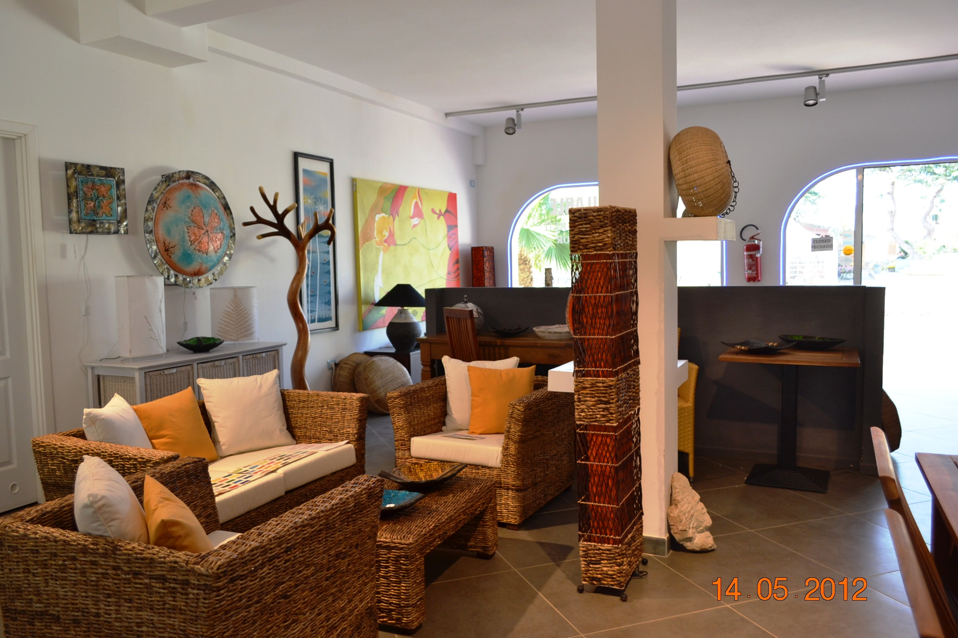

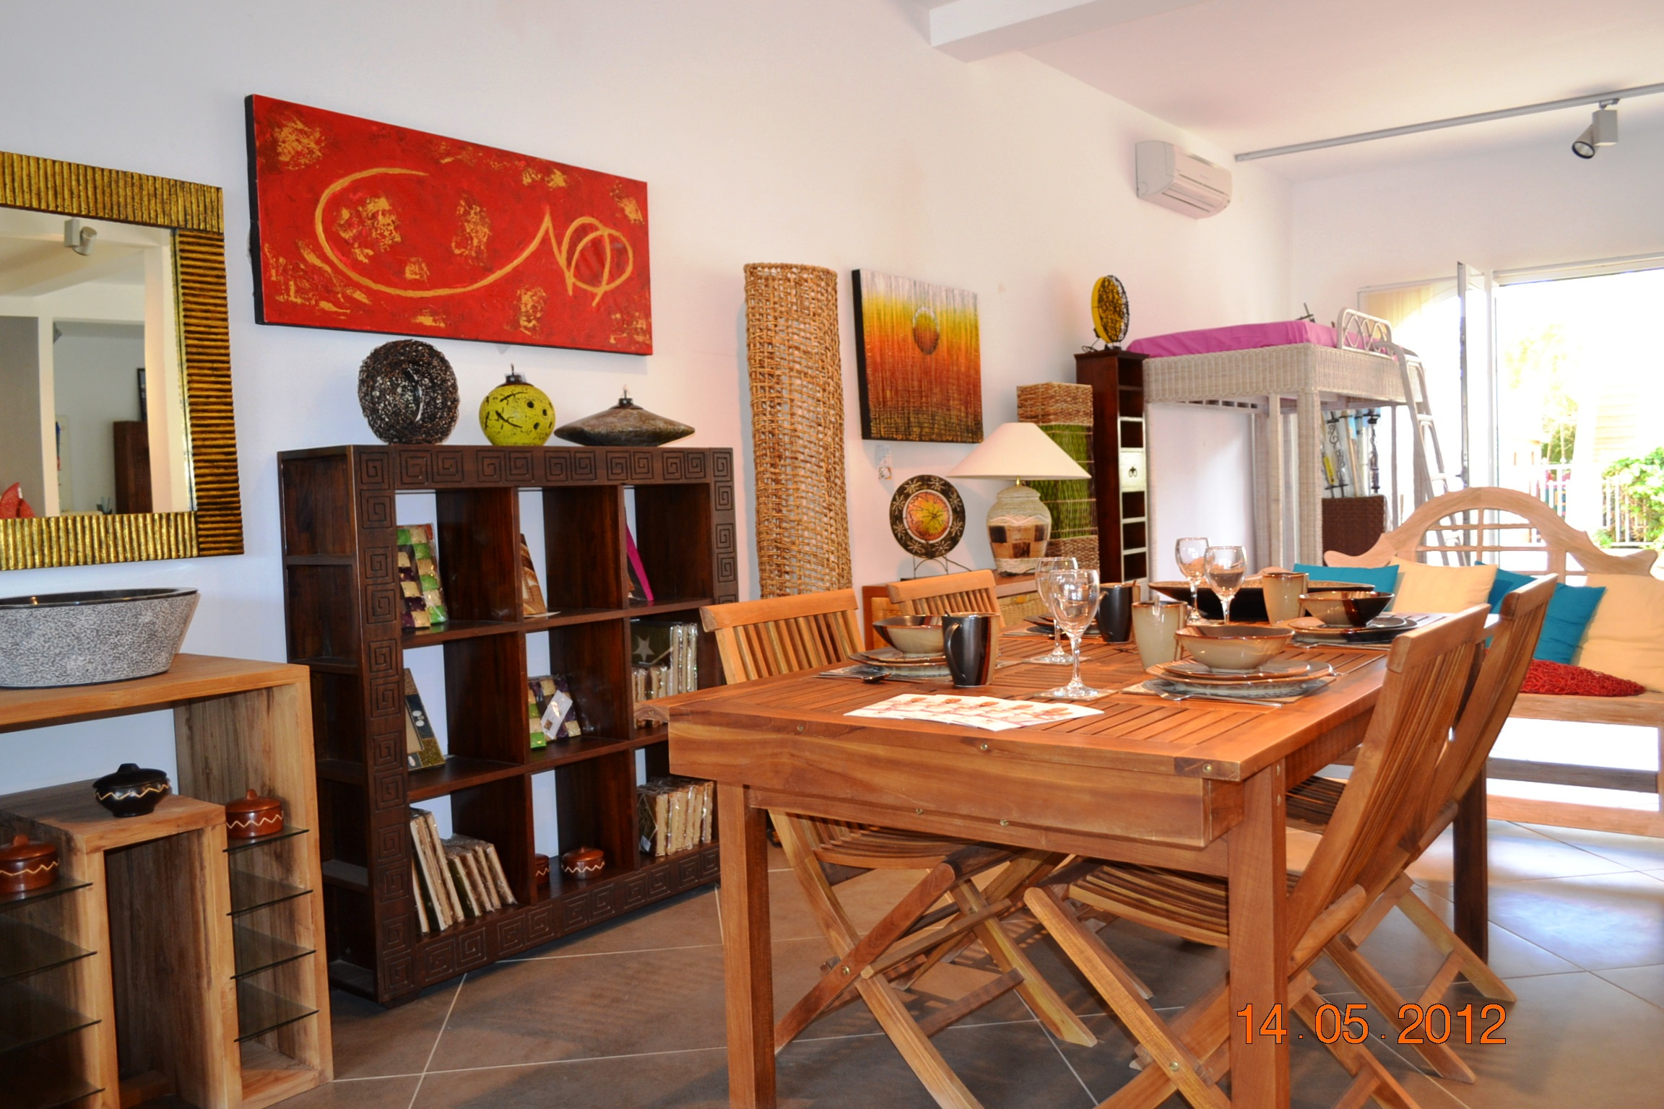

Right of the main square, Santa Maria, Sal
Tel: 00238 – 9183330 or 00238 - 9859318
www.aigacaboverde.com Facebook: Aigagroup Caboverde

Photos of AIGA showroom in Santa Maria, Sal

